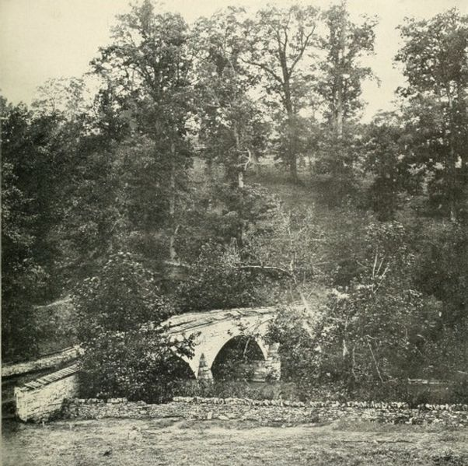
Union Perspective
Burnside had 12,500 men with which to attack the Confederate position across Antietam creek. In order to stop any Confederate retreat back into Virginia, the Union had to cross the bridge or find another way over Antietam creek to advance. The bridge is 12 feet wide.
This is the view that the 12,500 Union soldiers under General Burnside had of the stone bridge. The Confederates controlled the high ground across the bridge.
General Burnside has sent his staff officers (you) ahead to survey the situation. Study the terrain (photo) and be prepared to report on the following questions:
What are our advantages? Disadvantages?
Should we attack? Do you have an alternate plan?

