Mapping Lee’s Orders
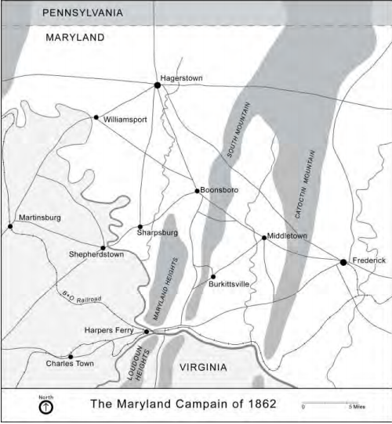
Directions: Read the copy of Lee’s orders and then map the routes each force was to take. Use a different color for each group and place a * at the final destination for each. Remember to complete the key.
Stonewall Jackson General Longstreet
General McLaws General Walker
General Stuart General Hill
What are the advantages and disadvantages of this plan?

