Historybook Pilgrims

Submitted by Danny Helton
Northview Middle School, Sevier County Schools

Objectives:
- Students will use a combination of primary and secondary sources to investigate the background of the Pilgrims aboard Mayflower.

- Students will use background information to create a Historical Fiction Facebook page for different Pilgrims aboard the Mayflower.

Standards:
- 8.5.spi.11. identify conclusions about historical events using primary and secondary sources

- 8.5.spi.17. interpret a historical event from multiple perspectives

- 8.6.spi.1. identify the impact of individual and group decisions on historical events

Materials:
- Mayflower passenger list (Worksheet A). Biographical information for Mayflower passengers available at http://mayflowerhistory.com/mayflower-passenger-list/

- Biographical Guide (Worksheet B)

- “Mock Facebook” (Historybook) page (Worksheet C). Template available at www.Freeology.com

- Internet accessible computers for student research.

Background Knowledge: Students will need the following background knowledge prior to this lesson:
- Similarities and differences between Anglicans, Puritans, and Separatists in England.

- Reasons why the Pilgrims chose to leave England for Holland and later America.

- The Mayflower and its voyage to America.

Lesson Day 1:

- Introduction- Begin the lesson by first reviewing over the 3 main Protestant groups found in England in the early 1600s- Anglicans, Puritans, and Separatists. Include that the Pilgrims were Separatists who left England for religious reasons.

- Passengers- Assign students different individuals from the Mayflower Passenger list.

- Research- Students will use the research guide to gather information about his/her specific passenger.

Lesson Day 2:

- Construction- Students will create Historybook pages from the information gathered about his/her Mayflower Passenger. Encourage students to create a first person Historybook page of the passenger aboard the Mayflower including contacts, possible conversations, and statuses. The more students take a first person point of view the more realistic the Historybook page becomes.

Assessment/Presentation- Students may present and explain his/her Historybook page or pages may be mounted around the room or in the hallway for everyone to see.

Variations/suggestions
- Print 11”X17” Historybook pages at Staples, OfficeMax, etc for students to create posters rather than standard 8 ½” X11” copies.
- Complete at different time intervals- before voyage, during voyage, and upon arrival at Plymouth.

Worksheet A: Mayflower Passenger List
John Alden
Isaac and Mary (Norris) Allerton, and children Bartholomew, Remember, and Mary
John Allerton
John and Eleanor Billington, and sons John and Francis
William and Dorothy (May) Bradford
William and Mary Brewster, and children Love and Wrestling
Richard Britteridge
Peter Browne
William Butten
Robert Carter
John and Katherine (White) Carver
James and Mrs. Chilton, and daughter Mary
Richard Clarke
Francis Cooke and son John
Humility Cooper
John Crackstone and son John
Edward Doty
Francis and Sarah Eaton, and son Samuel
Thomas English
Moses Fletcher
Edward and Mrs. Fuller, and son Samuel
Samuel Fuller
Richard Gardiner
John Goodman
William Holbeck
John Hooke
Stephen and Elizabeth (Fisher) Hopkins and children Constance, Giles and Damaris; son Oceanus was born during the voyage.
John Howland
John Langmore
William Latham
Edward Leister
Edmund Margesson
Christopher and Mary (Prower) Martin
Desire Minter
Ellen, Jasper, Richard, and Mary More
William and Alice Mullins and children Priscilla and Joseph
Degory Priest
Solomon Prower
John and Alice Rigsdale
Thomas Rogers and son Joseph
Henry Samson
George Soule
Myles and Rose Standish
Elias Story
Edward Thompson
Edward and Agnes (Cooper) Tilley
John and Joan (Hurst) Tilley and daughter Elizabeth
Thomas and Mrs. Tinker, and a son
William Trevore
John Turner, and two sons
Richard Warren
William and Susanna White, and son Resolved (son Peregrine was born shipboard in Provincetown Harbor after arrival).
Roger Wilder
Thomas Williams
Edward and Elizabeth (Barker) Winslow
Gilbert Winslow
“Mr. Ely”
Dorothy (John Carver’s maidservant)

Worksheet B

Biographical Guide

Person

Birth Date

Birthplace

Current Location (At that time period)

Religion

Job/occupation

People this person interacted with (contacts)

Family

Quote by or about the person

Information about the person

Worksheet C

History Book
Likes:
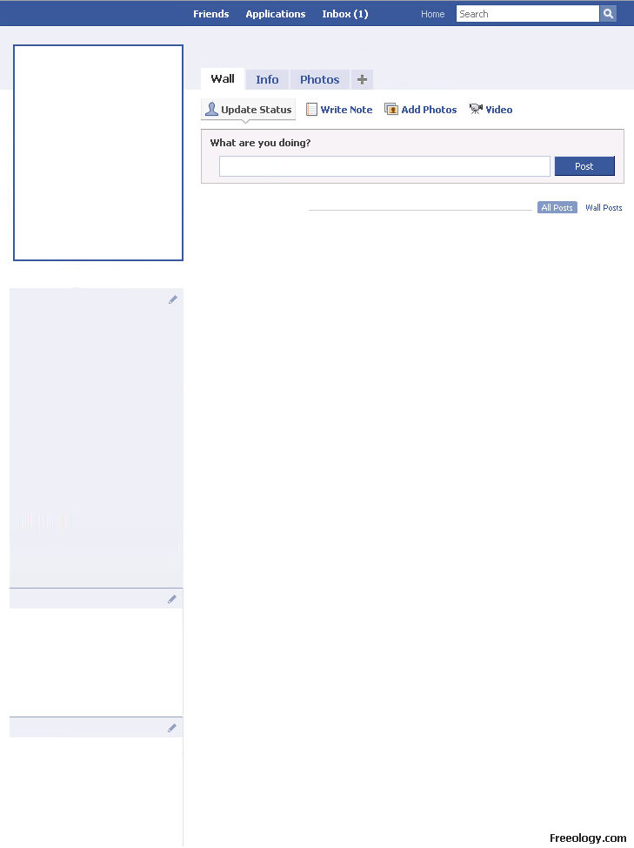
Status:
About Me:
Info:
Sex:

Birthday:

Place of Birth:

Hometown:

Email:

Work:

Religion:
Friends:
Family:
__________________________________________________________________________________________________________________________________________________________________________________________________________________
____________________________________________________________________________________________________________________________________________

__________________________________________________________________________________________________________________________________________________________________________________________________________________
______________________________________________________________________________________________________________________________________________________________________________________________________________________________________________________________________________________________________________________________________________________________

Quote:
__________________________________________________________________________________________________________________________________________________________________________________________________________________

____________________________________________________________________________________________________________________________________________

