Determining Significance: Civil Rights Movement Activity
Teacher’s Guide

Standards: 5.65, US 20, US 90, US 91, US92

For this activity, students should be divided into groups. Each group will be given information and a picture of an event from the Civil Rights Movement. The students should work together to complete the graphic organizer. When the organizer is complete each group should explain the significance of the event they analyzed for the class.
The Murder of Emmet Till
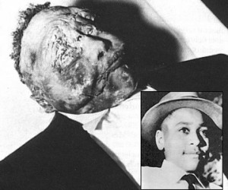

Between the end of Reconstruction in 1877 and the mid-1960s, the United States saw repeated acts of homegrown terrorism. During that period, more than 5,000 blacks were lynched, shot or had their homes bombed.

Each story was horrific in its own way. But for the most part they produced few or no efforts to end the violence. In the late 1930s, an anti-lynching bill brought before the U.S. House of Representatives failed. And the legalized murders of blacks continued, eliciting occasional pity but doing little to galvanize a movement and create legislation.

But the murder in Mississippi of a 14-year-old Chicago boy would change all that.

Mississippi’s reputation as the bastion of white supremacy and the capital of white terrorism was well deserved. Like many states in the Deep South, it effectively operated as a police state with no regard for the rights of blacks.

There’s still a lack of clarity about the facts that made Emmett a murder target. The conventional story is that while leaving a convenience store, he whistled at a white woman. There have been other theories that suggest Emmett, who had a stuttering problem, had been encouraged to whistle in order to prepare to speak. Mae Mobley Till, who died in 2003, always believed that her son’s attempt to whistle – or “wolf whistle” – may have been misinterpreted and cost him his life.
That night, several armed white men showed up at his uncle’s home and took Emmett away. It was the last time anyone saw him alive.

When his body was fished out of the Tallahatchie River a few days later, he was a grotesque sight. He’d been beaten, shot in the head, had one of his eyes gouged out and had his skull, wrists and leg fractured.
Unlike Lee and Smith, authorities did arrest and try suspects in the Emmett’s murder, but a jury acquitted them.

Emmett’s death did not lead to any legislation. And it did not help give blacks the right to vote – at least not right away. But it forced a response among millions of blacks around the country that said one thing: enough. Enough of the lynchings, the bombings, wanton assassinations, being denied the right to vote, and being treated like second-class citizens.

Emmett’s horrific death strongly influenced the thinking of an Alabama seamstress named Rosa Parks that late December 1955 afternoon when she refused to give up her seat for a white man. Her principled stand sparked the greatest revolution in American history.
In the end, although his murderers never went to prison, Emmett Till’s death was not in vain.

Make a case for historical significance:
Significance for Advocates of Civil Rights because. . . | Significance for those Opposed to Civil Rights. . . | Social, Political, Cultural Significance
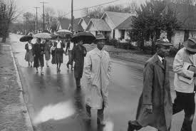
Montgomery Bus Boycott

Sparked by the arrest of Rosa Parks on 1 December 1955, the Montgomery bus boycott was a 13-month mass protest that ended with the U.S. Supreme Court ruling that segregation on public buses is unconstitutional. The Montgomery Improvement Association (MIA) coordinated the boycott, and its president, Martin Luther King, Jr., became a prominent civil rights leader as international attention focused on Montgomery. The bus boycott demonstrated the potential for nonviolent mass protest to successfully challenge racial segregation and served as an example for other southern campaigns that followed. In Stride Toward Freedom, King’s 1958 memoir of the boycott, he declared the real meaning of the Montgomery bus boycott to be the power of a growing self-respect to animate the struggle for civil rights.
The roots of the bus boycott began years before the arrest of Rosa Parks. The Womens’ Political Council (WPC), a group of black professionals founded in 1946, had already turned their attention to Jim Crow practices on the Montgomery city buses. In a meeting with Mayor W. A. Gayle in March 1954, the council's members outlined the changes they sought for Montgomery’s bus system: no one standing over empty seats; a decree that black individuals not be made to pay at the front of the bus and enter from the rear; and a policy that would require buses to stop at every corner in black residential areas, as they did in white communities. When the meeting failed to produce any meaningful change, WPC president Jo Ann Robinson reiterated the council’s requests in a 21 May letter to Mayor Gayle, telling him, ‘‘there has been talk from twenty-five or more local organizations of planning a city-wide boycott of busses’’(‘‘A Letter from the Women’s Political Council’’).
A year after the WPC’s meeting with Mayor Gayle, a 15-year-old named Claudette Colvin was arrested for challenging segregation on a Montgomery bus. Seven months later, 18-year-old Mary Louise Smith was arrested for refusing to yield her seat to a white passenger. Neither arrest, however, mobilized Montgomery’s black community like that of Rosa Parks later that year.
King recalled in his memoir that ‘‘Mrs. Parks was ideal for the role assigned to her by history,’’ and because ‘‘her character was impeccable and her dedication deep-rooted’’ she was ‘‘one of the most respected people in the Negro community’’ (King, 44). Robinson and the WPC responded to Parks’ arrest by calling for a one-day protest of the city’s buses on 5 December 1955. Robinson prepared a series of leaflets at Alabama State College and organized groups to distribute them throughout the black community. Meanwhile, after securing bail for Parks with Clifford and Virginia Durr, E. D. Nixon, past leader of the Montgomery chapter of the National Association for the Advancement of Colored People (NAACP), began to call local black leaders, including Ralph Abernathy and King, to organize a planning meeting. On 2 December, black ministers and leaders met at Dexter Avenue Baptist Church and agreed to publicize the 5 December boycott. The planned protest received unexpected publicity in the weekend newspapers and in radio and television reports.
On 5 December, 90 percent of Montgomery’s black citizens stayed off the buses. That afternoon, the city’s ministers and leaders met to discuss the possibility of extending the boycott into a long-term campaign. During this meeting the MIA was formed, and King was elected president. Parks recalled: ‘‘The advantage of having Dr. King as president was that he was so new to Montgomery and to civil rights work that he hadn’t been there long enough to make any strong friends or enemies’’ (Parks, 136).
That evening, at a mass meeting at Holt Street Baptist Church, the MIA voted to continue the boycott. King spoke to several thousand people at the meeting: ‘‘I want it to be known that we’re going to work with grim and bold determination to gain justice on the buses in this city. And we are not wrong.… If we are wrong, the Supreme Court of this nation is wrong. If we are wrong, the Constitution of the United States is wrong. If we are wrong, God Almighty is wrong’’ (Papers 3:73). After unsuccessful talks with city commissioners and bus company officials, on 8 December the MIA issued a formal list of demands: courteous treatment by bus operators; first-come, first-served seating for all, with blacks seating from the rear and whites from the front; and black bus operators on predominately black routes.
The demands were not met, and Montgomery’s black residents stayed off the buses through 1956, despite efforts by city officials and white citizens to defeat the boycott. After the city began to penalize black taxi drivers for aiding the boycotters, the MIA organized a carpool. Following the advice of T. J. Jemison, who had organized a carpool during a 1953 bus boycott in Baton Rouge, the MIA developed an intricate carpool system of about 300 cars. Robert Hughes and others from the Alabama Council for Human Relations organized meetings between the MIA and city officials, but no agreements were reached.
In early 1956, the homes of King and E. D. Nixon were bombed. King was able to calm the crowd that gathered at his home by declaring: ‘‘Be calm as I and my family are. We are not hurt and remember that if anything happens to me, there will be others to take my place’’ (Papers 3:115). City officials obtained injunctions against the boycott in February 1956, and indicted over 80 boycott leaders under a 1921 law prohibiting conspiracies that interfered with lawful business. King was tried and convicted on the charge and ordered to pay $500 or serve 386 days in jail in the case State of Alabama v. Martin Luther King, Jr. Despite this resistance, the boycott continued.
Although most of the publicity about the protest was centered on the actions of black ministers, women played crucial roles in the success of the boycott. Women such as Robinson, Johnnie Carr, and Irene West sustained the MIA committees and volunteer networks. Mary Fair Burks of the WPC also attributed the success of the boycott to ‘‘the nameless cooks and maids who walked endless miles for a year to bring about the breach in the walls of segregation’’ (Burks, ‘‘Trailblazers,’’ 82). In his memoir, King quotes an elderly woman who proclaimed that she had joined the boycott not for her own benefit but for the good of her children and grandchildren (King, 78).
National coverage of the boycott and King’s trial resulted in support from people outside Montgomery. In early 1956 veteran pacifists Bayard Rustin and Glenn E. Smiley visited Montgomery and offered King advice on the application of Gandhian techniques and nonviolence to American race relations. Rustin, Ella Baker, and Stanley Levison founded In Friendship to raise funds in the North for southern civil rights efforts, including the bus boycott. King absorbed ideas from these proponents of nonviolent direct action and crafted his own syntheses of Gandhian principles of nonviolence. He said: ‘‘Christ showed us the way, and Gandhi in India showed it could work’’ (Rowland, ‘‘2,500 Here Hail’’). Other followers of Gandhian ideas such as Richard Gregg, William Stuart Nelson, and Homer Jack wrote the MIA offering support.
On 5 June 1956, the federal district court ruled in Browder v. Gayle that bus segregation was unconstitutional, and in November 1956 the U.S. Supreme Court affirmed Browder v. Gayle and struck down laws requiring segregated seating on public buses. The court’s decision came the same day that King and the MIA were in circuit court challenging an injunction against the MIA carpools. Resolved not to end the boycott until the order to desegregate the buses actually arrived in Montgomery, the MIA operated without the carpool system for a month. The Supreme Court upheld the lower court’s ruling, and on 20 December 1956 King called for the end of the boycott; the community agreed. The next morning, he boarded an integrated bus with Ralph Abernathy, E. D. Nixon, and Glenn Smiley. King said of the bus boycott: ‘‘We came to see that, in the long run, it is more honorable to walk in dignity than ride in humiliation. So … we decided to substitute tired feet for tired souls, and walk the streets of Montgomery’’ (Papers 3:486). King’s role in the bus boycott garnered international attention, and the MIA’s tactics of combining mass nonviolent protest with Christian ethics became the model for challenging segregation in the South.

Significance for Advocates of Civil Rights because. . . | Significance for those Opposed to Civil Rights. . . | Social, Political, Cultural Significance
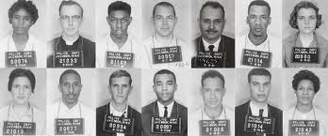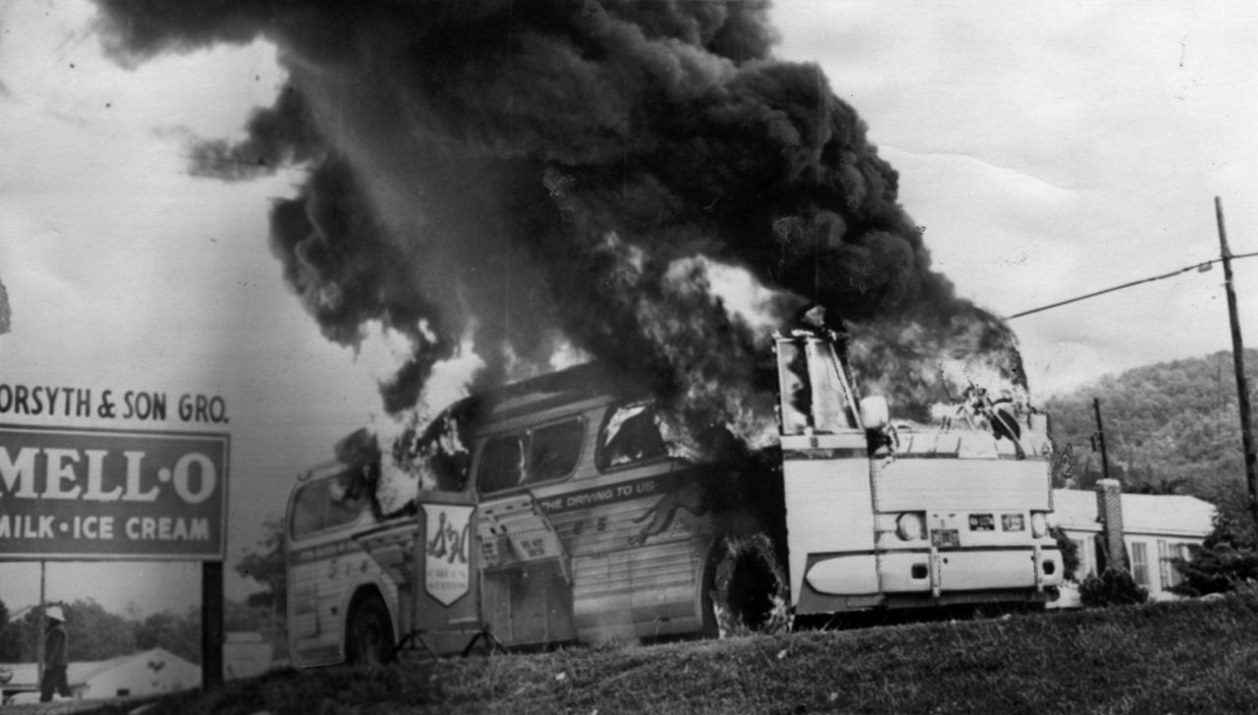
Freedom Riders
The First Freedom Ride took place on May 4, 1961 when seven blacks and six whites left Washington, D.C., on two public buses bound for the Deep South. They intended to test the Supreme Court's ruling in Boynton v. Virginia (1960), which declared segregation in interstate bus and rail stations unconstitutional.
In the first few days, the riders encountered only minor hostility, but in the second week the riders were severely beaten. Outside Anniston, Alabama, one of their buses was burned, and in Birmingham several dozen whites attacked the riders only two blocks from the sheriff's office. With the intervention of the U.S. Justice Department, most of CORE's Freedom Riders were evacuated from Birmingham, Alabama to New Orleans. John Lewis, a former seminary student who would later lead SNCC and become a US congressman, stayed in Birmingham.

CORE Leaders decided that letting violence end the trip would send the wrong signal to the country. They reinforced the pair of remaining riders with volunteers, and the trip continued. The group traveled from Birmingham to

Montgomery without incident, but on their arrival in Montgomery they were savagely attacked by a mob of more than 1000 whites. The extreme violence and the indifference of local police prompted a national outcry of support for the riders, putting pressure on President Kennedy to end the violence.

The riders continued to Mississippi, where they endured further brutality and jail terms but generated more publicity and inspired dozens more Freedom Rides. By the end of the summer, the protests had spread to train stations and airports across the South, and in November, the Interstate Commerce Commission issued rules prohibiting segregated transportation facilities.
Significance for Advocates of Civil Rights because. . . | Significance for those Opposed to Civil Rights. . . | Social, Political, Cultural Significance
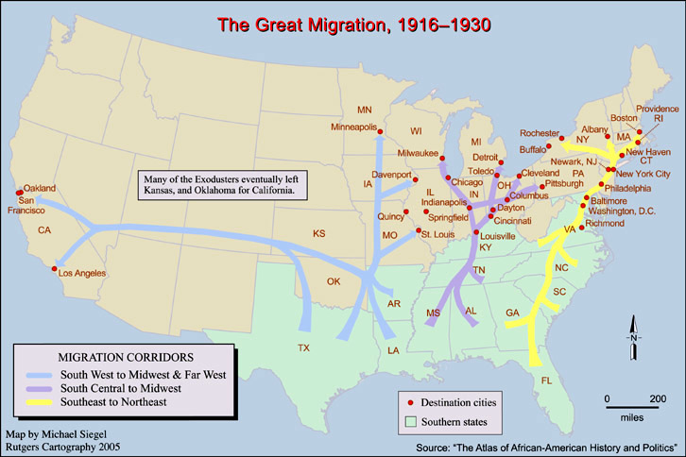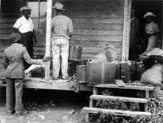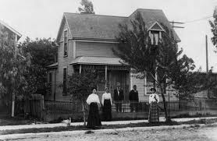

The Great Migration

Between 1915 and 1970, more than 6 million African-Americans moved out of the South to cities across the Northeast, Midwest and West.
This relocation — called the Great Migration — resulted in massive demographic shifts across the United States. Between 1910 and 1930, cities such as New York, Chicago, Detroit and Cleveland saw their African-American populations grow by about 40 percent, and the number of African-Americans employed in industrial jobs nearly doubled.
"[The Great Migration] had such an effect on almost every aspect of our lives — from the music that we listen to to the politics of our country to the ways the cities even look and feel, even today," says Isabel Wilkerson. "The suburbanization and the ghettos that were created as a result of the limits of where [African-Americans] could live in the North [still exist today.] And ... the South was forced to change, in part because they were losing such a large part of their workforce through the Great Migration."

Significance for Advocates of Civil Rights because. . . | Significance for those Opposed to Civil Rights. . . | Social, Political, Cultural Significance
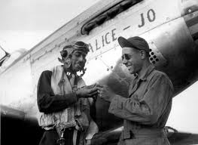
African Americans in WWII

African Americans served bravely and with distinction in every theater of World War II, while simultaneously struggling for their own civil rights from “the world’s greatest democracy.” Although the United States Armed Forces were officially segregated until 1948, WWII laid the foundation for post-war integration of the military. In 1941 fewer than 4,000 African Americans were serving in the military and only twelve African Americans had become officers. By 1945, more than 1.2 million African Americans would be serving in uniform on the Home Front, in Europe, and the Pacific (including thousands of African American women in the Women’s auxiliaries).

During the war years, the segregation practices of civilian life spilled over into the military. The draft was segregated and more often than not African Americans were passed over by the all-white draft boards. Pressure from the NAACP led President Roosevelt to pledge that African Americans would be enlisted according to their percentage in the population. Although this percentage, 10.6%, was never actually attained in the services during the war, African American numbers grew dramatically in the Army, Navy, Army Air Force, Marine Corps, and the Coast Guard.

While most African Americans serving at the beginning of WWII were assigned to non-combat units and relegated to service duties, such as supply, maintenance, and transportation, their work behind front lines was equally vital to the war effort. Many drove for the famous “Red Ball Express,” which carried a half million tons of supplies to the advancing First and Third Armies through France. By 1945, however, troop losses virtually forced the military to begin placing more African American troops into positions as infantrymen, pilots, tankers, medics, and officers in increasing numbers. In all positions and ranks, they served with as much honor, distinction, and courage as any American soldier did. Still, African American MPs stationed in the South often could not enter restaurants where their German prisoners were being served a meal.

On D-Day, the First Army on Omaha and Utah Beaches included about 1,700 African American troops. This number included a section of the 327th Quartermaster Service Company and the 320th Anti-Aircraft Barrage Balloon Battalion, which protected troops on the beach from aerial attack. Soon the all-black 761st Tank Battalion was fighting its way through France with Patton’s Third Army. They spent 183 days in combat and were credited with capturing 30 major towns in France, Belgium, and Germany.

The Army Air Force also established several African American fighter and bomber groups. The famous “Tuskegee Airmen” of the 332nd Fighter Group became part of the 15th Air Force, flying ground support missions over Anzio and escorting bombers on missions over Southern Italy. The Tuskegee Airmen flew more than 15,000 sorties May 1943 and June 1945. Bomber crews often requested to be escorted by these “Redtails,” a nicknamed acquired from the painted tails of Tuskegee fighter planes. Sixty-six Tuskegee Airmen died in combat.

Stephen Ambrose identified the lamentable American irony of WWII, writing, “The world’s greatest democracy fought the world’s greatest racist with a segregated army” (Ambrose, Citizen Soldier). During the global conflict, African American leaders and organizations established the “Double V” campaign, calling for victory against the enemy overseas and victory against racism at home. This new black consciousness and the defiant rejection of unjustifiable racism planted important seeds for the post-War civil rights movement.
Significance for Advocates of Civil Rights because. . . | Significance for those Opposed to Civil Rights. . . | Social, Political, Cultural Significance
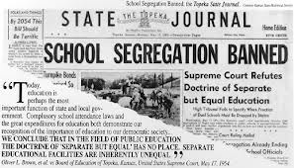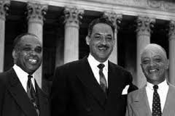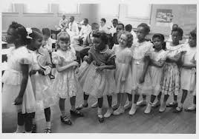
Brown v. Board of Education

Brown v. Board of Education, 347 U.S. 483 (1954), was a landmark United States Supreme Court case in which the Court declared state laws establishing separate public schools for black and white students unconstitutional. The decision overturned the Plessy v. Ferguson decision of 1896 which allowed state-sponsored segregation. Handed down on May 17, 1954, the Warren Court's unanimous (9–0) decision stated that "separate educational facilities are inherently unequal." As a result, de jure racial segregation was ruled a violation of the Equal Protection Clause of the Fourteenth Amendment of the United States Constitution. This ruling paved the way for integration and was a major victory of the civil rights movement.

Significance for Advocates of Civil Rights because. . . | Significance for those Opposed to Civil Rights. . . | Social, Political, Cultural Significance

