Interpreting the Art of Western Expansion:

Manifest Destiny on the March

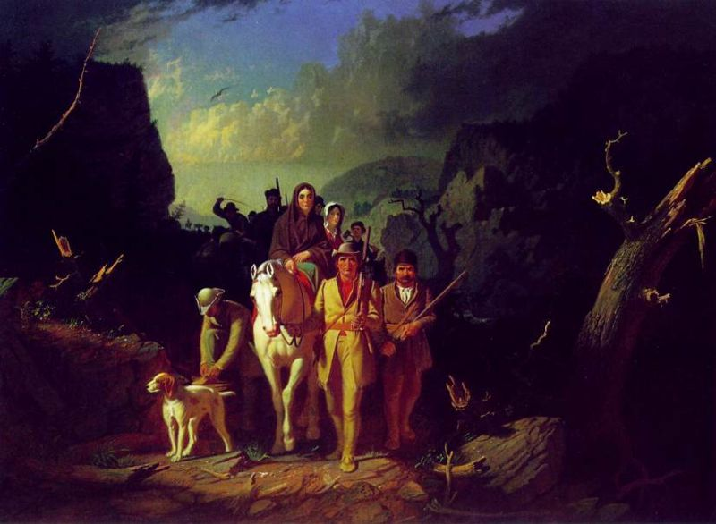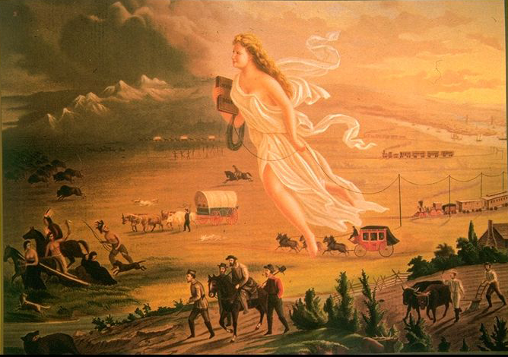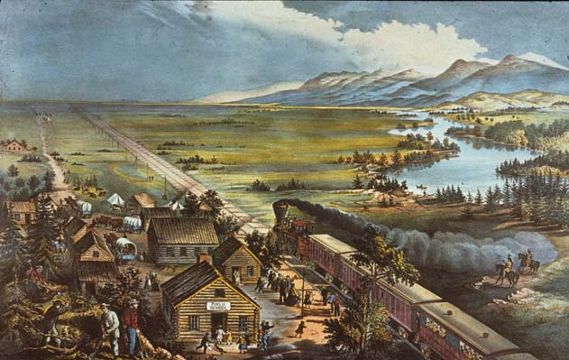
“The existence of an area of free land, its continuous recession, and the advance of American settlement westward explains American development”
—Frederick Jackson Turner, “The Significance of the Frontier in American History” (1893)

The words of historian Frederick Jackson Turner exemplified the first generation of professional historians in the late nineteenth and early twentieth century, who believed that history should be regarded as a science. Turner and several of his professional contemporaries incorporated Darwin’s evolutionary theory to reveal the contours of American history. Just as one species surpassed another, so one frontier environment succeeded another in the course of American expansion. Turner portrayed Americans as developing distinctive virtues of their own—individualism, egalitarianism, pragmatism, voluntarism, and a martial spirit—as each successive frontier they founded grew more remote from English antecedents. These American virtues, played out continuously throughout the American continent as settlers marched westward, embodied much that was distinctive, and indeed, much that was good about America. In other words, Turner argued that westward migration—fueling the rapid expansion of the United States throughout the 19th century—represented a democratic movement of people, who were trained in ruggedness and served as community builders as they quickly evolved from a savage frontier stage through a pastoral and ranching stage to finally a urban and manufacturing stage, thus creating America as they went along. “American social development has been continually beginning over again on the frontier,” argued Turner. Each western American community thus recapitulated the growth and evolution of civilization. Turner’s view of westward expansion was a positive outlook that held the key to the American character.

In spite of this positive and progressive view of westward expansion, which is captured in the work of some of America’s earliest and most noted artists, Turner’s view of American development ignored the social, political, economic, legal, and environmental consequences of the westward movement. However, these consequences are also evident in the work of some of these artists despite the original intentions of the artists. A careful examination of 3 key paintings depicting America’s westward expansion serve as a powerful window into not only the time in which the paintings were created but also into the time in which the canvases capture. Each painting in itself, serves as a powerful lesson into the development of the United States. No one image can reflect the diversity of American history, but these images capture westward expansion.
George Caleb Bingham, “Daniel Boone Escorting Settlers Through the Cumberland Gap” (1850-51) Library of Congress
Missouri artist George Caleb Bingham's Daniel Boone Escorting Settlers through the Cumberland Gap is among the most popular American paintings addressing the theme of westward expansion. Rich with symbolism, it helped establish the mythic status of Daniel Boone and legends of western settlement. Like Charles Wimar in The Abduction of Daniel Boone's Daughter by the Indians (1853), Bingham drew from Christian and classical imagery to justify and glamorize westward expansion and the ideal of Manifest Destiny, or the providential mission of the American nation to settle the frontier. Referring to Boone's first journeys into Kentucky in the early 1770s, the group is pictured traveling from east to west, dramatically emerging from the sun-filled landscape in the background and crossing into the dark, foreboding landscape in the foreground, where the snarled trees help signify the dangerous power of nature. Portrayed with idealized features and poses, the intrepid Boone, a rifle resting on his shoulder, suggests the figure of Moses—an archetype for pioneer patriarchs—leading his people toward the Promised Land, while Rebecca Boone, atop the horse, suggests the Virgin Mary, symbolizing the courageous spirit of pioneer women. The painting also reflects Boone leading an orderly procession through a wilderness pass, advocating community versus laissez-faire individualistic ideas.
John Gast, “American Progress” (1872) Library of Congress

Excerpts from explanatory text that George A. Croffut provided to market John Gast's 1872 lithograph American Progress:

This rich and wonderful country--the progress of which at the present time, is the wonder of the old world--was until recently, inhabited exclusively by the lurking savage and wild beasts of prey. If the rapid progress of the "Great West" has surprised our people, what will those of other countries think of the "Far West," which was destined at an early day, to be the vast granary [grain producing region], as it is now the treasure chamber of our country?...

In the foreground, the central and principal figure, a beautiful and charming Female, is floating westward through the air bearing on her forehead the "Star of Empire...." On the right of the picture is a city, steamships, manufactories, schools and churches over which beams of light are streaming and filling the air--indicative of civilization. The general tone of the picture on the left declares darkness, waste and confusion. From the city proceed the three great continental lines of railway.... Next to these are the transportation wagons, overland stage, hunters, gold seekers, pony express, pioneer emigrant and the warrior dance of the "noble red man." Fleeing from "Progress"...are Indians, buffaloes, wild horses, bears, and other game, moving Westward, ever Westward, the Indians with their squaws, papooses, and "pony lodges," turn their despairing faces towards, as they flee the wondrous vision. The "Star" is too much for them....

What home, from the miner's humble cabin to the stately marble mansion of the capitalist, should be without this Great National Picture, which illustrates in the most artistic manner all the gigantic results of American Brains and Hands! Who would not have such a beautiful token to remind them of the country's grandeur and enterprise which have caused the mighty wilderness to blossom like the rose!!!

In John Gast's portrayal of America's westward movement, bison herds and Indians retreat as a radiant “Manifest Destiny”—stringing telegraph wire in her wake—leads homesteaders and other settlers, wagons, and railroads across the Great Plains.

“American Progress” represents the enduring mythology of “Manifest Destiny,” first enunciated in 1839 in the pages of John L. O’Sullivan’s Democratic Review, which struck a responsive chord among Americans as Sullivan announced that it had become the United States’ “manifest destiny to overspread the continent allotted by Providence for the free development of our yearly multiplying millions.”

As with so much of our frontier history, the details left out are as interesting as those that were included.

Analyzing Gast’s “American Progress” Panel by Panel

1. Railroads

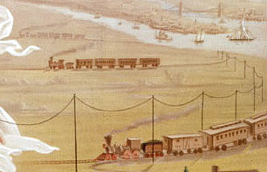

The railroad tracks push right into the prairie grass, in a nice metaphor for the driving force of technology.

2. Native Americans

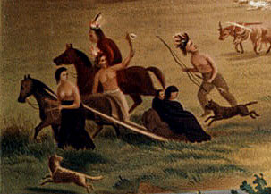

Like naïve savages, the Indians flee from the white goddess of progress. Their tomahawk, bow-and-arrow, and travois sled will be no match for guns and railroads. Of course, Native Americans in the West were in fact well acquainted with European technology by the 1800s. Moreover, few groups fled from progress. Rather, most used the fruits of progress, such as the rifle, to fight for self-determination.

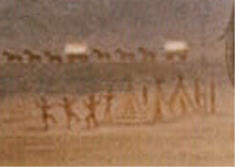

Could this be a portrayal of a savage dance, as seen from a white?

3. Pioneers

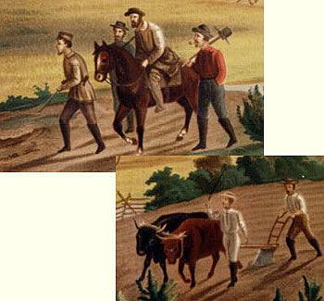

In Gast's vision, white pioneers—and white labor—pave the way for westward expansion. In fact, African Americans were heavily represented among the laborers who emigrated west. Moreover, the expansion of slavery played a crucial political role among the forces that pushed the country westward.

Fanny Palmer, “Across the Continent: Westward the Course of Empire Takes Its Way” (1868) Library of Congress

Fanny Palmer’s, “Across the Continent: Westward the Course of Empire Takes its Way,” printed by Currier & Ives in 1868, fairly teems with icons of the nation's faith in its “manifest destiny”—a frontier settlement at the edge of civilization is the last stop on the wagon trail, while newly-laid train tracks stretch west to the horizon.

In Palmer’s version, the train is the center focus. She applauds the coming of the railroad, giving prominence to its tracks—they cut diagonally across the center of the picture—and placing them next to a prosperous town with well-dressed families and human structures (cabins, church, and schoolhouse) that symbolize the refinements of religion and education. On the railcars is lettered, “Through Line New York San Francisco,” predicting the completion of the first transcontinental railroad in May of the following year.

Her intention is to represent through her art how the United States developed rapidly throughout the country during the 19th century. On one side of the train is a town, where children are pictured playing and men are pictured working. Palmer is showing how settlements westward were civilizing and industrializing, becoming distinctively American and transforming everything in its path.

On the other side of the town, Native Americans are pictured. They are divided from the town by the train. The print forcefully represents the displacement of Native Americans by making the train’s smoke a barrier between the two Indian horsemen and the wild country—or hunting grounds—lying ahead. The smoke entraps the Native Americans in Palmer’s vision of the West like American development entrapped them on reservations. The buffalo herd retreating toward a distant mountain range symbolizes the disappearing wilderness. Palmer’s version does not capture the beauty of the west, but instead shows the viewer the development of the west.

For most of the century, the New York firm of Nathan Currier and James Ives was immensely popular as "Publishers of Colored Engravings for the People." Their prints of familiar American scenes, selling for 5¢ to 25¢ apiece, were easy to understand and were executed without artiness.

