Women’s Suffrage Activity
Standards: 5.46, US.18,
Background
ALICE PAUL & THE NATIONAL WOMAN’S PARTY: FROM “SILENT SENTINELS” TO RADICAL AGITATORS
Shortly after President Woodrow Wilson assumed the presidency, Alice Paul and her organization, the Woman’s National Party (NWP), as well as countless other groups of suffragist women, led numerous delegations to plead with Wilson to support woman suffrage, but to little avail. Meanwhile, Carrie Chapman Catt, the president of the National American Woman Suffrage Association (NAWSA) continued pressing on the local level with similar results. By 1916, both the Democratic and Republican parties, under heavy pressure from women’s groups, adopted woman suffrage planks in their national platforms. Even Wilson promised support; however, his endorsement was hedged by advocating state-by-state decisions rather than backing a federal suffrage amendment.

By January 1917, the nation’s attention was overtaken by war in Europe. On January 7, 1917, Wilson received a delegation of the NWP, headed by Paul, pressing for a federal amendment. But Wilson remained steadfast that he supported action taken by the states rather than the federal government. The following day, the NWP stationed a “perpetual delegation” from 10 a.m. to 5:30 p.m., 6 days a week in front of the White House so that, according to Paul, “he wouldn’t forget.” These “Silent Sentinels” became the first group in American history to employ this form of protest. They remained posted at the White House gates, rain or shine, day after day.

By the summer of 1917, the suffragists became more restive, and the placards became more provocative. They called the president “Kaiser Wilson,” he was burned in effigy by Sue Shelton White of Henderson, Tennessee, and signs stated that there was no real democracy in the United States. Onlookers heckled the women, snatched and broke their signs, pushed and shoved them, and even called them traitors. Wilson, too, was becoming impatient.

The suffragists were hauled to jail on charges of obstructing the sidewalk or refusing to cooperate with police. Some were convicted and sentenced to prison terms up to six months in the District of Columbia jail and the Occoquan Workhouse in Virginia. Alice Paul told reporters as she was led from the courtroom to begin her sentence that “We are being imprisoned, not because we obstructed traffic, but because we pointed out to the President the fact that he was obstructing the cause of democracy at home, while Americans were fighting for it abroad.” In all, 218 women from 26 states were arrested, 97 of whom went to prison. Of those whom went to prison, they insisted that they be regarded as political prisoners. Several, including Alice Paul, went on hunger strikes. Authorities responded with a harsh and cruel procedure of “forcible feedings,” done with tubing forced down the mouth or nostrils, three times a day. The radicalism of the NWP created a situation in which something had to be done. They made President Wilson and Congress nervous about what they might do next.
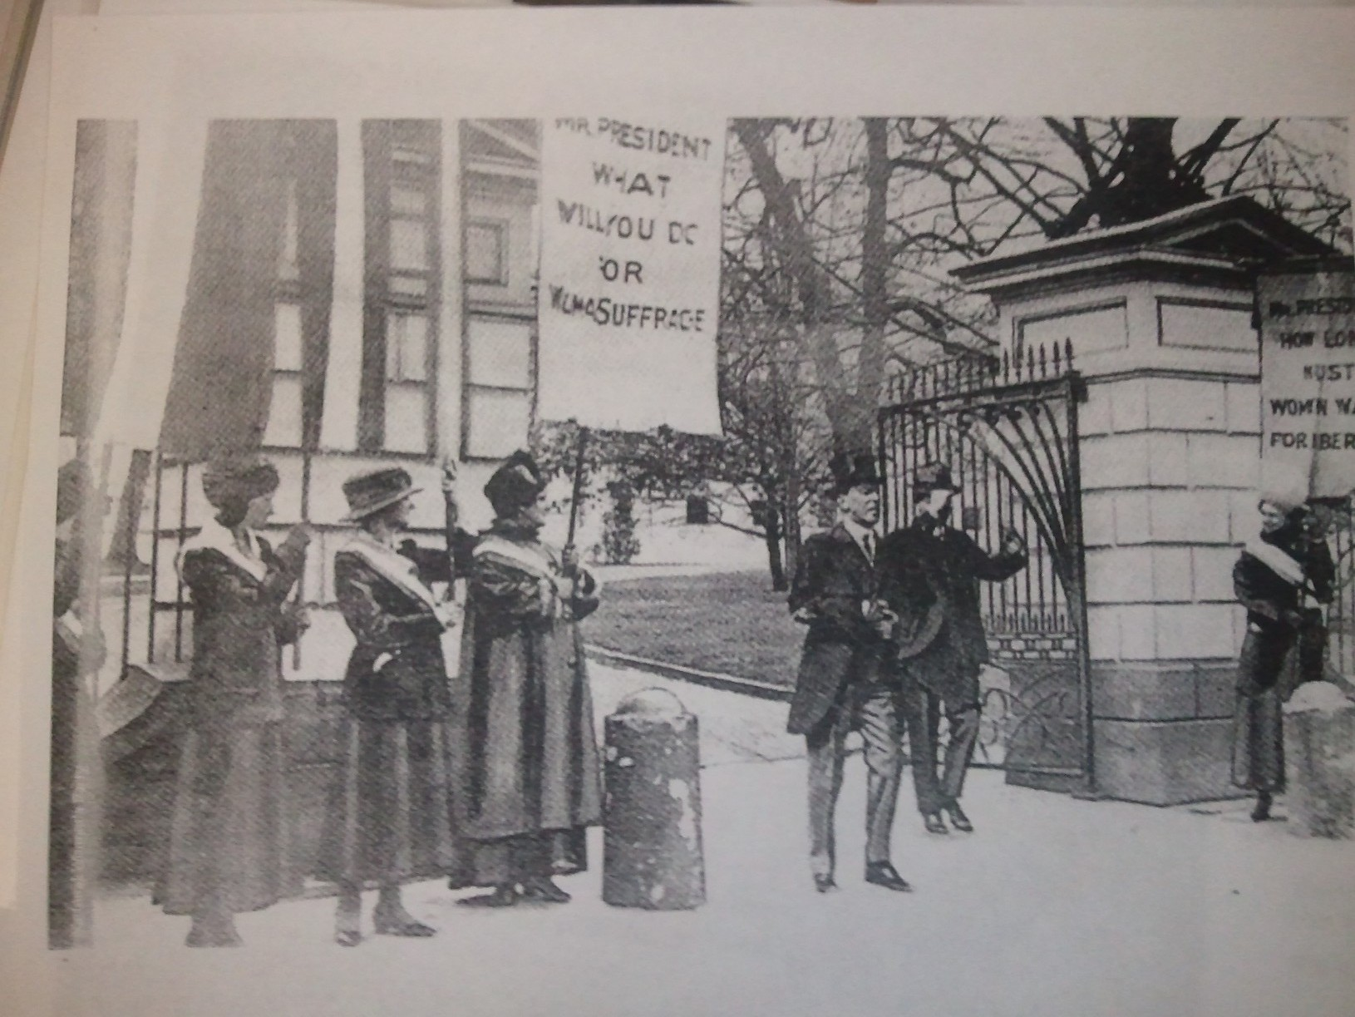
Image: President Woodrow Wilson ignoring women’s suffrage pickets at the northeast gates of the White House. (Carol Yellin & Janann Sherman, The Perfect 36: Tennessee Delivers Woman Suffrage, Oak Ridge, TN: Iris Publishers, 1998)

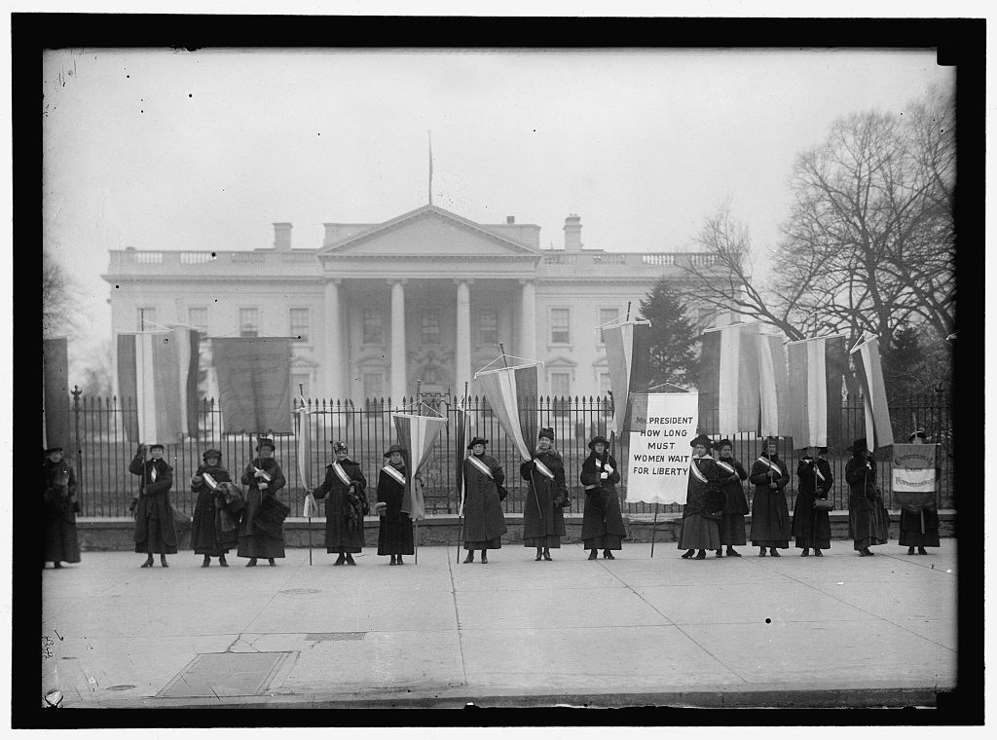
Image: Women’s Suffrage Pickets at the gates of the White House, Library of Congress

DISCUSSION QUESTIONS: Spend a few minutes examining the photograph on the front.

1. Describe this image. What are the women doing? Why are there only women in this image?

2. How is “place” important in this image? What do you think were the benefits of picketing in front of the White House? What costs might this strategy have had for the National Woman’s Party? Would the meaning of this image be the same if these women were protesting somewhere else?

3. What does the legible sign say and what does it mean? What are they waiting for the President to do?

4. The words are not visible on the second banner from the left. What might you have written on a protest sign?

5. What was the point of including slogans on picketers’ banners? Why might these slogans provoke onlookers?

6. Do you think is a violent or non-violent form of protest?

7. Do you think these women are wealthy or poor? What clues are provided in this image?

8. Would you be willing to stand out in the cold to stand up for your rights? What rights would you defend?

