Marching for the Vote
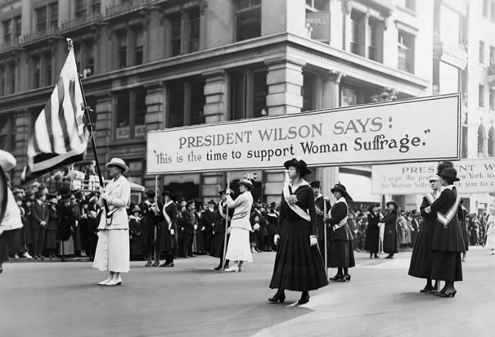
US History, 11th grade

Unit duration: Four 90-minute blocks
Day One: Introduce women’s suffrage and the leaders behind the movement
Day Two: Alice Paul, Sewall-Belmont House, the march, Tennessee’s role in ratification of the 19th Amendment
Day Three: Introduce and watch film, ‘Iron Jawed Angels’
Day Four: Finish & discuss film, wrap up unit with discussion and test

*This unit has been created to cover the movement and journey leading to the ratification of the 19th Amendment.

State Standards covered:
Era 7: Emergence of Modern America (1890-1930)
Learning Expectations:
Standard Number 1.0: Culture
Understand social tensions and their consequences after the turn of the century.
Understand the cultural changes in the early 20th century.
Standard Number 4.0: Governance and Civics
Understand the reforms and changes in American politics and government as a
result of the Progressive Movement.
Understand the governmental policies that affected America and the world during
the 1890s- 1930s.
Performance Indicators State:
As documented through state assessment,
7.3 Recognize the progress of political and social reform in America during this
era (i.e., Women's Suffrage, Regulation of food and drug, Initiative, Referendum, and
Recall, protection of workers' rights, Antitrust Supreme Court decisions,
Muckrakers).
7.6 Recognize the role of Tennessee in the women's suffrage movement. (i.e., "the
perfect 36", Anne Dallas Dudley, Harry Burn, Governor Albert Roberts).

Day One: Introduction
- KWL chart followed by discussion
- Lecture on key terms and focus points
- Textbook: in small groups, read selection in text
- Primary Sources activity
Day Two: Alice Paul and friends, Tennessee involvement, & 19th Amendment
- Alice Paul biography
- Sewell-Belmont house in Washington, DC (the events that took place while the NWP was working)
- Picketing and marching, the White House and the streets of Washington, DC
- Tennessee’s role in the ratification of the 19th Amendment (Albert Roberts, Harry Burn)
- Watch short music video ‘Bad Romance: Women’s Suffrage’ by Soomo Publishing https://www.youtube.com/watch?v=IYQhRCs9IHM
Day Three: Introduce the film, ‘Iron Jawed Angels’
- Explain the force feedings before the movie begins
- Watch film
Day Four: Closing
- Finish film
- Discuss film
- Discuss unit
- Assess students through written test

Websites visited:
http://www.alicepaul.org/alicepaul.htm Alice Paul biography
https://www.youtube.com/watch?v=IYQhRCs9IHM SoomoPublishing, ‘Bad Romance: Women’s Suffrage’
http://www.sewallbelmont.org/learn/overview/ Sewell-Belmont House information
http://memory.loc.gov/ammem/collections/suffrage/nwp/ NWP
http://www.teachamericanhistory.org/file/harry_t._burn.pdf Harry Burn letter from mother
http://www.archives.gov/global-pages/larger-image.html?i=/historical-docs/doc-content/images/19th-amendment-l.jpg&c=/historical-docs/doc-content/images/19th-amendment.caption.html 19th Amendment

