Radio, WSM and the Grand Ole Opry
Table of Contents

- Content Essay

- Elementary Activity

- Middle/High School Activity

- Primary Source: Images
Pages 2-3

4-5

6-7

8-9

Radio, WSM and the Grand Ole Opry

Essential Questions: Why was WSM created? What factors led to the popularity of the Grand Ole Opry?
The history of WSM and the Grand Ole Opry starts in the early days of radio. Nikola Tesla realized that the key to making radio waves work as a form of communication was individualization. In other words, you needed to be able to select the signal you wanted to hear and cancel out the rest. Italian Guglielmo Marconi used Tesla’s ideas to create and market his Wireless Telegraph Company. At first, the U.S. Patent Office rejected Marconi’s patent claims, but later reversed that decision and granted the patents to Marconi in 1904. This set the stage for American corporations to start building and selling radio to the public.
In order to boost sales of radios, Westinghouse set up the first commercial radio station, KDKA in 1920. Department stores soon followed suite, setting up their own stations to boost sales of radios. However, everyone who could afford a radio would eventually buy one. The radio stations’ only response to this economic blow was to sell advertising. The first radio advertisement was broadcast on August 28th, 1922. The idea of using radio to advertise other products and services revolutionized the medium and led to the creation of WSM and the Grand Ole Opry.
In 1925, the National Life and Accident Insurance Company in Nashville began operating a radio station. Edwin Craig, the executive in charge of the project, believed that station would reach new customers and enhance the company’s image. The call letters WSM were based on the company’s motto: “We Shield Millions.” The station began broadcasting on October 5, 1925 from the National Life building in Nashville. At first, the station played mostly classical music. However, that would change on November 28, 1925.
On that date, George Hay, announcer and program director, launched a new show called the WSM Barn Dance. The show starred championship fiddler Uncle Jimmy Thompson playing the traditional music of Southern Appalachia. The show was a huge hit, but people wanted the opportunity to see their favorite musicians perform as well. Crowds begun coming to the offices to see the musicians play. This led the National Life Company to build an auditorium for the show. Hayes renamed the show The Grand Ole Opry in 1927.
Another important development in country music history occurred in 1927. Maybelle Addington Carter joined her cousin Sara and brother in law A.P. Carter to form the Carter Family. The trio traveled to Bristol, Virginia later that year and recorded several songs as part of the so called “Bristol Sessions”. The “Bristol Sessions” were part of a recording tour of Southern towns by Victor Talking Machine Company producer Ralph Peer. Peer hoped to find new talent and record blues, gospel, and “hillbilly” music.75 Sara’s voice and Maybelle’s distinctive g2uitar style which came to be known as “Carter Family Picking,” made the group an instant sensation and helped to popularize hillbilly or country music throughout the nation
As it grew, the Opry moved to various locations around Nashville until finally moving to

Musicians who played the Opry quickly became stars. On December 8, 1945, Bill Monroe brought to the Opry stage a group of musicians who invented a new musical style called “bluegrass.” “The Original Bluegrass Band,” as the musicians called themselves, were Bill Monroe on mandolin, Earl Scruggs on the banjo, and Lester Flatt on the guitar. Other stars who found fame on the Opry stage include Minnie Pearl, Hank Williams Sr., Patsy Cline, Loretta Lynn, Johnny Cash and Mother Maybelle & The Carter Sisters. In 1974, The Grand Ole Opry moved from the Ryman Auditorium to a new facility on the grounds of Opryland. Performing at the Opry continues to be a career defining moment for country and bluegrass musicians.
Sources: “Who Invented Radio.” Tesla: Life and Legacy. Public Broadcasting Service, 2004. Web. 30 July, 2014. < http://www.pbs.org/tesla/ll/ll_whoradio.html>
“The First Commercial Radio Station.” About WPI. Worcester Polytechnic Institute, 2014. Web. 30 July 2014. < http://www.wpi.edu/about/history/radio.html>
McDonough, John. “First Radio Commercial Hit Airwaves 90 Years Ago.” Npr.org.
National Public Radio, 2012. < http://www.npr.org/2012/08/29/160265990/first-radio- commercial-hit-airwaves-90-years-ago>
Ryman.com. Ryman Auditorium, 2014. Web. 30 July, 2014. < http://ryman.com/>

Radio, WSM and the Grand Ole Opry

Complete the word search after reading the text on the rise of radio in Tennessee.

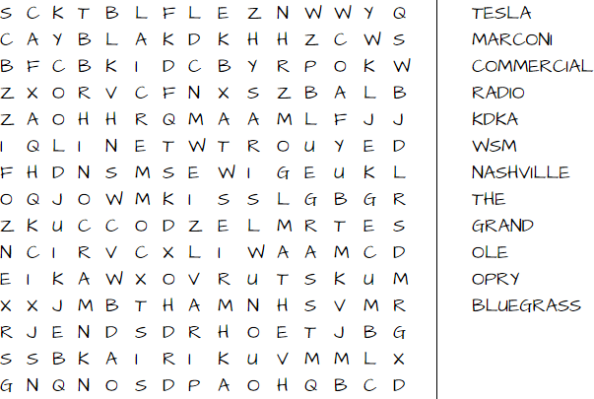

What similarities or differences do you see between the way people listened to music in the 1920’s and 1930’s compared to today?

_

Radio, WSM and the Grand Ole Opry Key

What similarities or differences do you see between the way people listened to music in the 1920’s and 1930’s compared to today?
Answers will vary but might include MP3 players, iTunes and internet music such as Spotify.

Radio, WSM and the Grand Ole Opry

Complete the word search after reading the text on the rise of radio in Tennessee.

Based on the text, what similarities do you see between how radios were used then and now? (Things to keep in mind: Advertising, Entertainment, Etc.)

Radio, WSM and the Grand Ole Opry Key
Complete the word search after reading the text on the rise of radio in Tennessee.
Based on the text, what similarities do you see between how radios were used then and now? (Things to keep in mind: Advertising, Entertainment, Etc.)
Answers will vary, but should address advertising and entertainment.

WSM and the Grand Ole Opry

Standards: 5.47, U.S. 44
These sources can all be found at the Tennessee State Library and Archives Virtual Archive. Click on the link to the TeVA site. You can download jpegs of the files by clicking the download icon in the upper right hand corner.

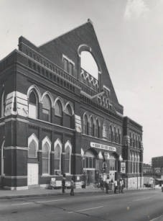
Ryman Auditorium exterior

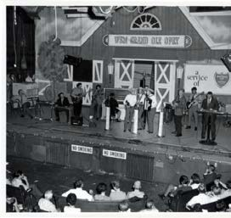
Grand Ole Opry cast onstage at the Ryman Auditorium

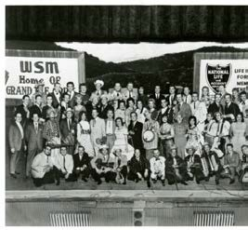
Grand Ole Opry cast on the stage of the Ryman Auditorium

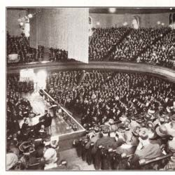
Ryman Auditorium interior, Hardeman's Tabernacle Sermons

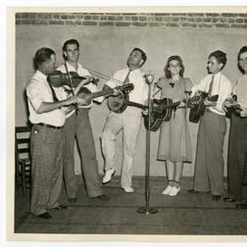
Country band playing WSM broadcast

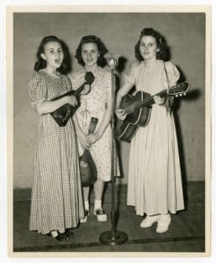
WSM singers

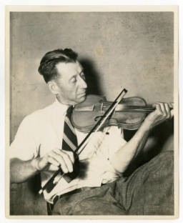
Man playing fiddle

