Pennsylvania and Native Americans

Concessions to the Province of Pennsylvania, 1681

Standards: 4.10, 8.9

Certain conditions, or concessions, agreed upon by William Penn, Proprietary and Governor of the province of Pennsylvania, find those who are the adventurers and purchasers in the same province, the eleventh of July, one thousand six hundred and eightyone.
…
XIII. That no man shall, by any ways or means, in word, or deed, … wrong any Indian, but he shall incur the same penalty of the law, as if he had committed it against his fellow planter, and if any Indian shall abuse, in word, or deed, any planter of this province, that he shall not be his own judge upon the Indian, but he shall make his complaint to the governor of the province, or his lieutenant, or deputy, or some inferior magistrate near him, who shall, to the utmost of his power, take care with the king of the said Indian, that all reasonable satisfaction be made to the said injured planter.

XIV. That all differences, between the planters and the natives, shall also be ended by twelve men, that is, by six planters and six natives; that so we may live friendly together… preventing all occasions of … mischief.

XV. That the Indians shall have liberty to do all things relating to improvement of their ground, and providing sustenance for their families, that any of the planters shall enjoy.
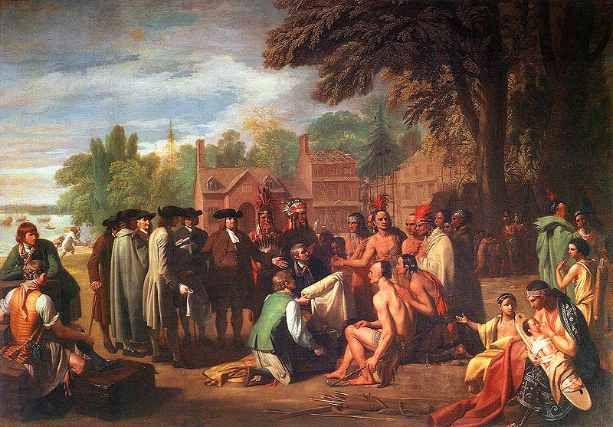

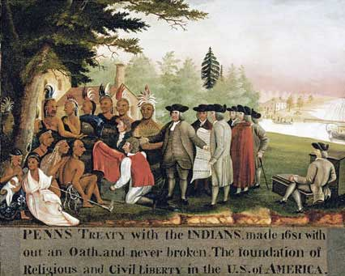
The Treaty of Penn with the Indians, Benjamin West, c. 1772

Penn’s Treaty with the Indians, Edward Hicks, c. 1840

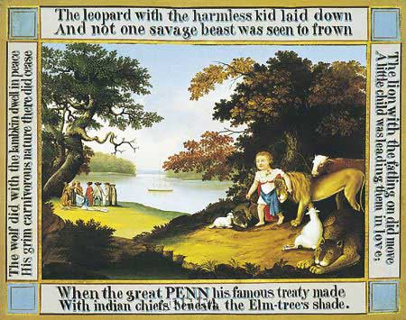

Peaceable Kingdom, Edward Hicks, c. 1834
Questions

1. How did William Penn’s religious beliefs influence his policy towards the Leni Lenape of Pennsylvania?

2. Why do you think William Penn established a policy of fair treatment to the Indians of
Pennsylvania?

3. Why were differences between colonists and Indians to be settled by six colonists and six Indians?

4. How do the artists Benjamin West and Edward Hicks portray Penn’s policy towards the Leni Lanape?

5. How accurate is Benjamin West’s painting Penn’s Treaty with the Indians? What evidence can you give to justify your answer?

6. What mood was Edward Hicks trying to accomplish by painting animals and children in the foreground of Peaceable Kingdom?

7. How are Hicks’ two paintings Peaceable Kingdom and Penn’s Treaty with the Indians similar?

8. Which of these paintings, if any, would you consider to be a primary source? Explain.

