Jamestown and Native Americans

Powhatan Speaks to Captain John Smith

Standards: 4.10, 8.9

Captain Smith, you may understand that I having seen the death…of my people…I know the difference of Peace and War better than any in my Country. …What will it avail you to take … by force what you may quickly have by love… What can you get by war, when we can hide our provisions and fly to the woods. . . . Think you I am so simple, not to know it is better to eat good meat, …sleep quietly…, laugh and be merry with you…then be forced to flee from all, to lie cold in the woods, feed upon Acorns, roots, and such trash, and be so hunted by you, that I can neither rest, eat, nor sleep…. Let this therefore assure you of our loves, and want of that, every year our friendly trade shall furnish you with Corn; and now also, if you would come in friendly manner to see us, and not thus with your guns and swords as to invade your foes.

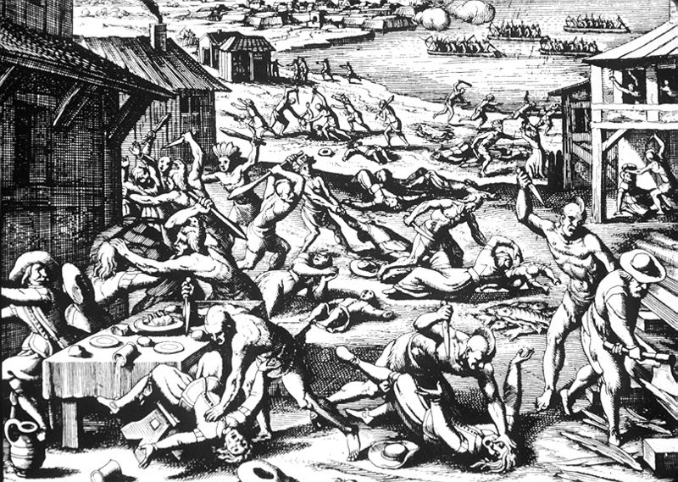

Theodor de Bry, 1628

Edward Waterhouse, The Barbarous Massacre, 1622

Thus have you scene the particulars of this massacre…wherein treachery and cruelty have done their worst to us, or rather to themselves; for whose understanding is so shallow, as not to perceive that this must needs be for the good of the Plantation. . . . Because our hands which before were tied with gentleness and fair usage, are now set at liberty by the treacherous violence of the Savages… So that we, who hitherto have had possession of no more ground than their waste, …now by right of War, and the law of Nations, invade the Country, and destroy them who sought to destroy us; whereby we shall enjoy their cultivated places…Now their cleared grounds in all their villages…shall be inhabited by us….

Victory of them may be gained many ways; by force, by surprise, by famine in burning their corn, by destroying and burning their Boats, Canoes, and Houses, breaking their fishing Wares, by assailing them in their hunting, where by they get the greatest part of their sustenance in Winter, by pursuing and chasing them with our horses, and blood-Hounds to draw after them…and tear them...Because the Indians who before were used as friends may now most justly be compelled to servitude and drudgery, and supply the room of men... [who] may employ themselves more entirely in their Arts and Occupations… while the Savages perform their inferior works…

Questions

1. What is Powhatan saying to Smith? How do you think Smith responded to Powhatan’s speech?

2. How does de Bry communicate the events of March 22, 1622 in his engraving?

3. Is de Bry’s portrayal of the attack on settlers at Jamestown a primary source? Explain why or why not?

4. Why did Edward Waterhouse argue that Opechancanough’s attack on the Virginia
settlements was actually good for the colonists?

5. What methods does he advise the setters to use in destroying the Indians?

